EXPT NO: 9 | TEXT CLASSIFICATION AND TEXT GENERATION USING TRANSFORMERS
DATE: 31.10.2026 | TEXT CLASSIFICATION AND TEXT GENERATION USING TRANSFORMERS

PRE-LAB QUESTIONS (PROVIDE BRIEF ANSWERS TO THE FOLLOWING QUESTIONS)

- What is a Transformer model in Natural Language Processing (NLP)?
A Transformer is a deep learning model used to understand and process human language. It uses an attention mechanism to understand the relationship between words in a sentence.

- What is BERT, and how is it used for text classification?
BERT stands for Bidirectional Encoder Representations from Transformers. It understands the context of words and classifies text into categories like positive, negative or neutral.

- What is fine-tuning in the context of pretrained language models?
Fine-tuning is the process of training an already pretrained model using a specific dataset. It helps the model perform a particular task more accurately.

- What is the difference between text classification and text generation?
Text classification assigns predefined labels to input text, such as positive or negative. Text generation creates new sentences or paragraphs based on the given input.

- What is a sequence-to-sequence model, and how is it used in text generation?
A sequence-to-sequence model converts an input sequence into an output sequence using an encoder and decoder. It is used for tasks like translation, summarization and text generation.
AIM
To implement text classification by fine-tuning a pretrained BERT model and develop a simple sequence-to-sequence text generation application using Transformer models.

SOFTWARE REQUIREMENTS
- Python
- Google Colab
- Hugging Face Transformers
- Hugging Face Datasets
- PyTorch
- NumPy
- Pandas
- Matplotlib

OBJECTIVES
Students will be able to:
- Understand the architecture and working of Transformer models in NLP.
- Understand the concepts of text classification and text generation.
- Load and preprocess text datasets for NLP applications.
- Fine-tune a pretrained BERT model for text classification.
- Evaluate the classification model using appropriate performance metrics.
- Implement a sequence-to-sequence application using a pretrained Transformer model.
- Generate text using the model's text generation capabilities.
- Analyze and compare the outputs produced by the Transformer models.

PROCEDURE
PART A: DATASET PREPARATION AND TEXT PREPROCESSING
Perform the following tasks:
- Load a text dataset such as the IMDb movie review dataset.
- Explore the dataset and examine sample text entries and their labels.
- Check the number of samples and the distribution of class labels.
- Separate the dataset into training and testing sets or use the predefined splits.
- Load a pretrained tokenizer corresponding to the BERT model.
- Tokenize the text using the tokenizer.
- Apply padding and truncation to maintain consistent input lengths.
- Convert the tokenized data into the required format for model training.
- Prepare the dataset for batch-wise processing.
(CODE: CONATAINS STUDENT ROLL NOS
SCREENSHOT OF CODE
SCREENSHOT OF OUTPUT)
PART B: FINE-TUNING BERT FOR TEXT CLASSIFICATION
Perform the following tasks:
- Load a pretrained BERT model for sequence classification.
- Configure the model for the required number of classes.
- Prepare the tokenized training and testing datasets.
- Define the training parameters, including learning rate, batch size, and number of epochs.
- Fine-tune the BERT model using the training dataset.
- Evaluate the trained model using the testing dataset.
- Calculate appropriate performance metrics, such as accuracy, precision, recall, and F1-score.
- Test the model using new text inputs.
- Display the predicted class labels and corresponding evaluation results.
- Save the fine-tuned model and tokenizer.
(CODE: CONATAINS STUDENT ROLL NOS
SCREENSHOT OF CODE
SCREENSHOT OF OUTPUT)

PART C: IMPLEMENTING A SEQUENCE-TO-SEQUENCE APPLICATION USING TRANSFORMERS
Perform the following tasks:
- Load a pretrained sequence-to-sequence Transformer model, such as T5-small.
- Load the corresponding tokenizer.
- Prepare a sample text input for the selected text generation task.
- Preprocess the input according to the model's requirements.
- Generate output text using the pretrained model.
- Apply appropriate generation parameters, such as maximum output length and beam search, where applicable.
- Display the input text and the generated output.
- Experiment with different input texts and generation settings.
- Observe how changes in the input and generation parameters affect the output.
- Save the generated outputs for further analysis.
(CODE: CONATAINS STUDENT ROLL NOS
SCREENSHOT OF CODE
SCREENSHOT OF OUTPUT)

PART D: MODEL TESTING AND OUTPUT ANALYSIS
Perform the following tasks:
- Test the fine-tuned BERT model using sample positive and negative text inputs.
- Record the predicted class labels for the test inputs.
- Analyze the classification results using the selected evaluation metrics.
- Test the sequence-to-sequence model using different input texts.
- Compare the generated outputs for different inputs and generation settings.
- Examine the relevance, readability, and coherence of the generated text.
- Identify possible errors or limitations in the classification and generation outputs.
- Compare the applications of BERT-based classification and sequence-to-sequence text generation.
- Summarize the observations obtained from both models.
(CODE: CONATAINS STUDENT ROLL NOS
SCREENSHOT OF CODE
SCREENSHOT OF OUTPUT)

EXPECTED OUTCOME
Students will understand the architecture and applications of Transformer models in Natural Language Processing. They will learn to fine-tune a pretrained BERT model for text classification, preprocess textual data, and evaluate classification performance using appropriate metrics. Students will also develop a simple sequence-to-sequence text generation application using a pretrained Transformer model and analyze the quality and relevance of the generated outputs.
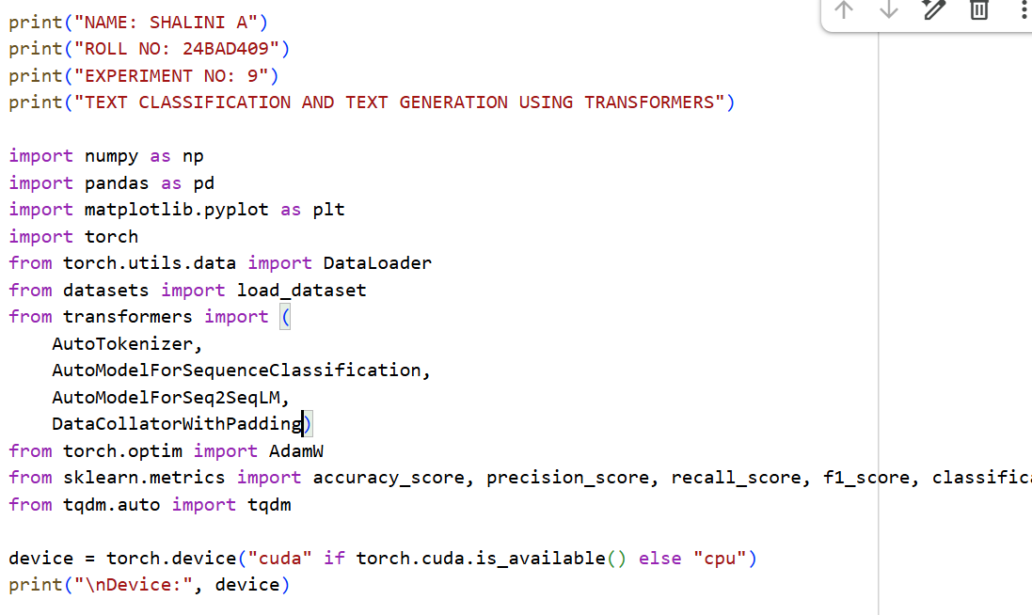
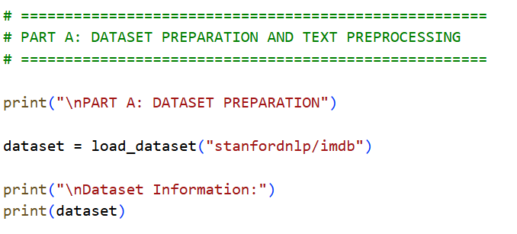

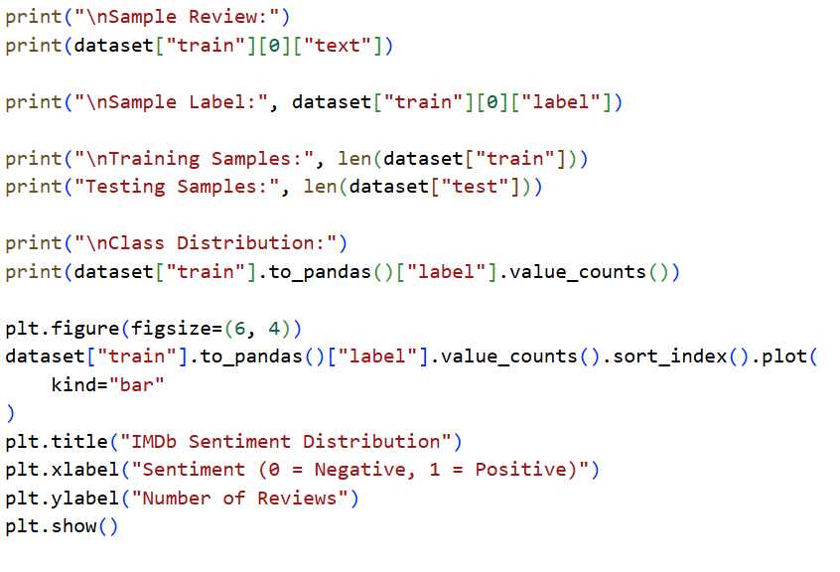
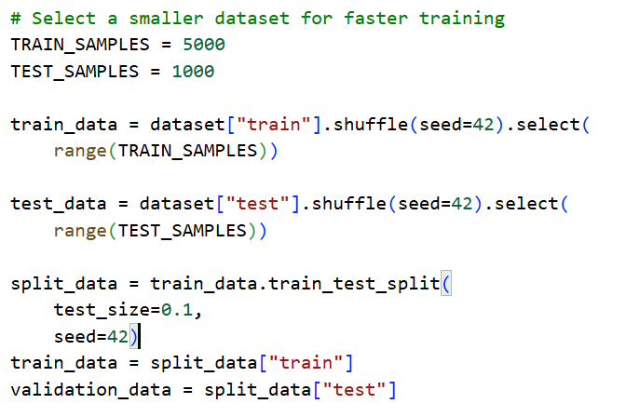
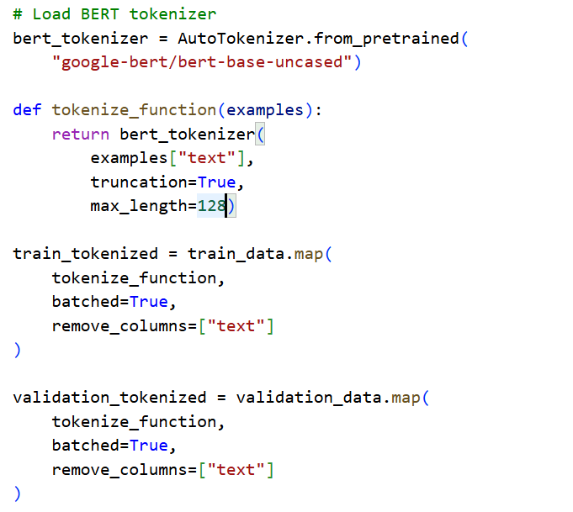
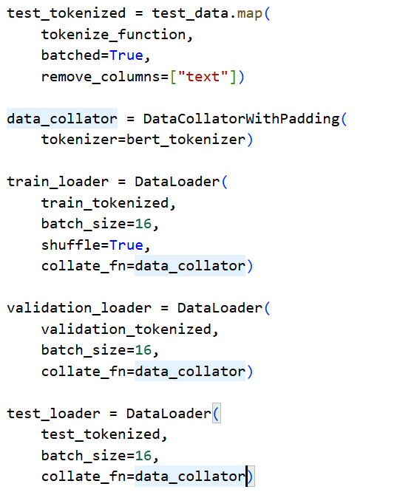
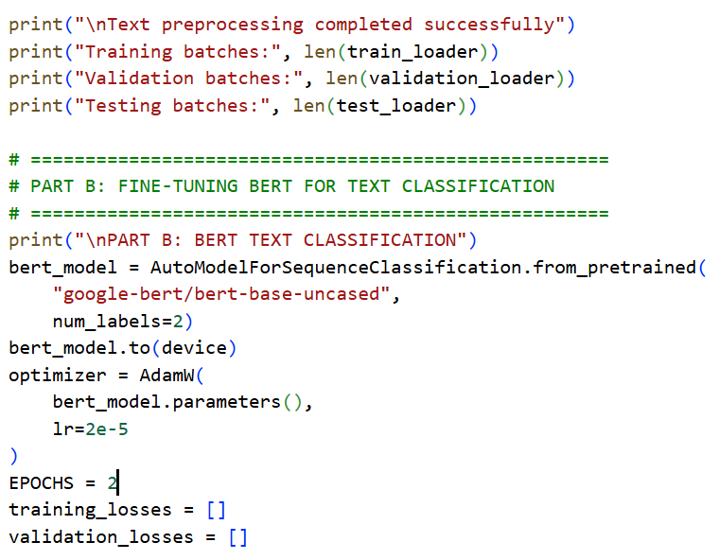
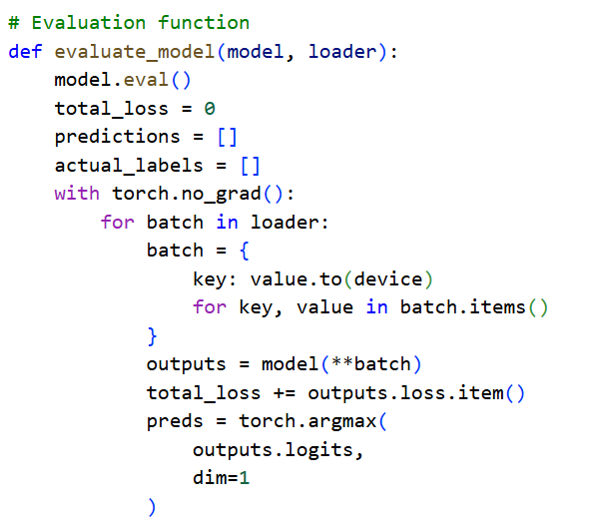

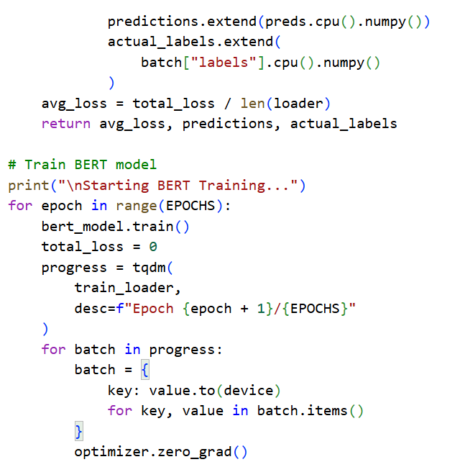
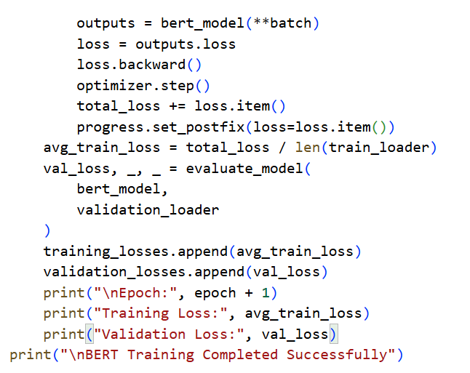
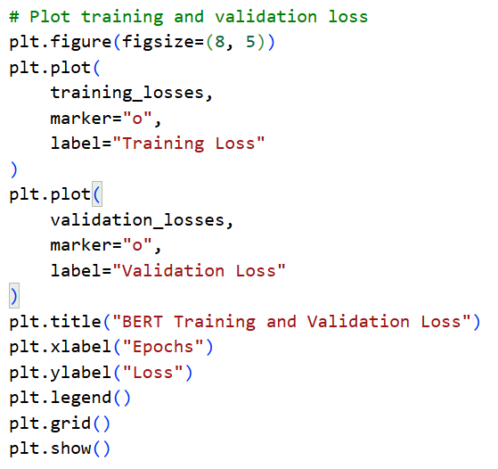
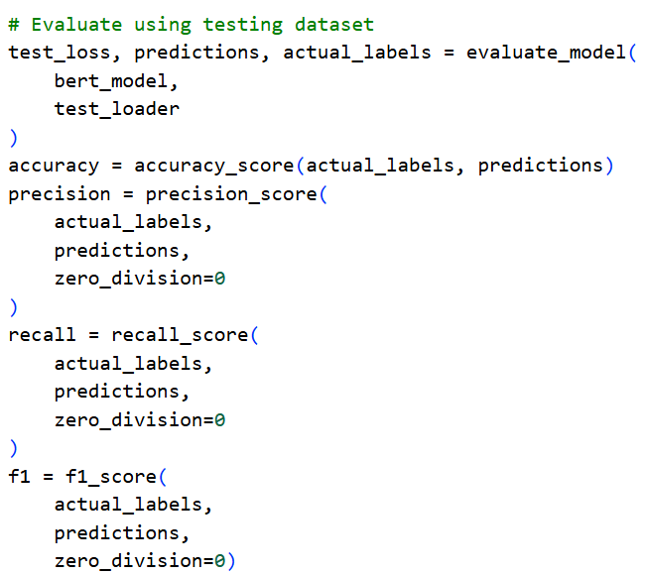
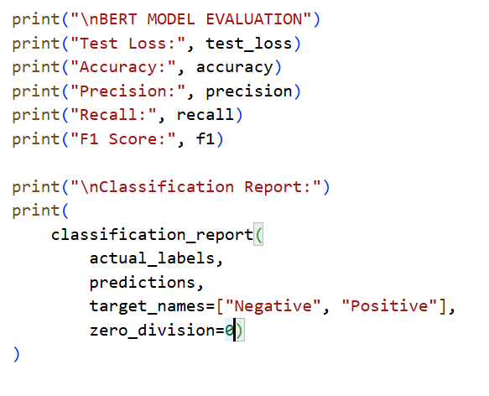
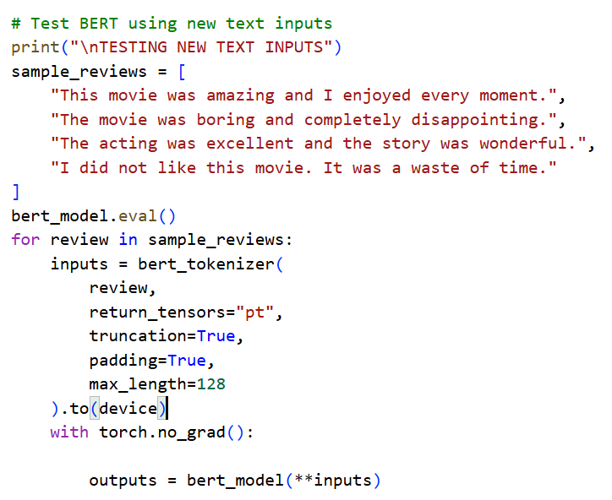

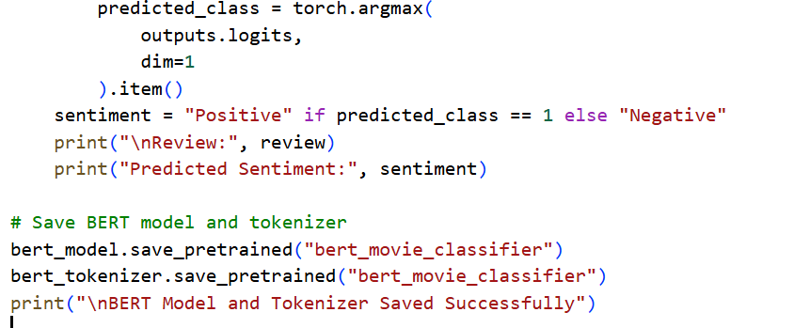
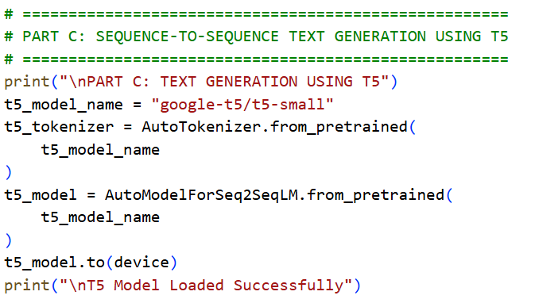
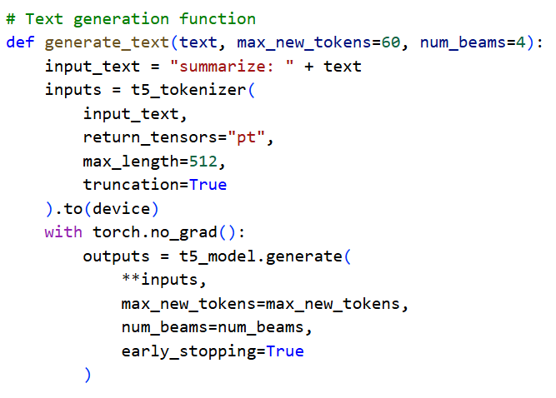
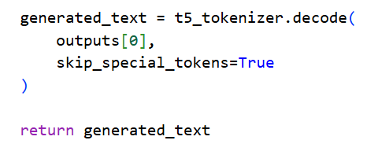
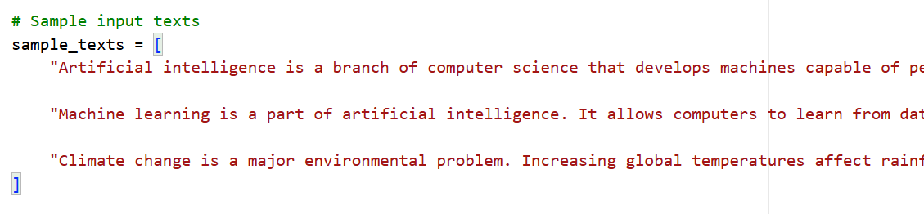

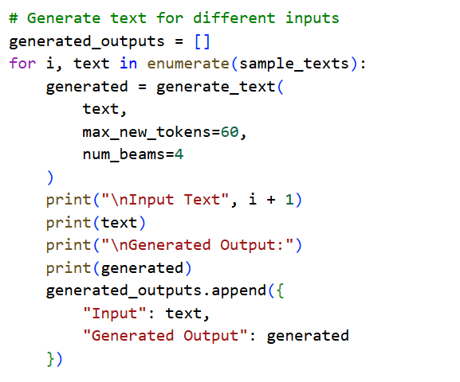
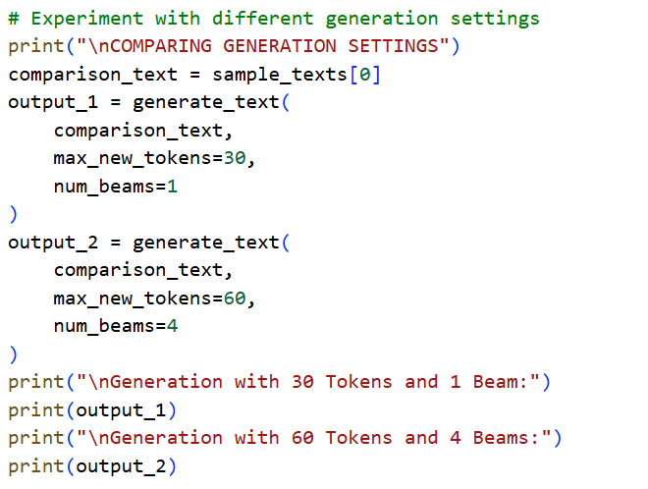
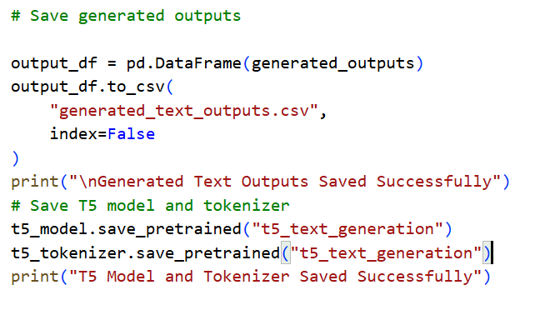
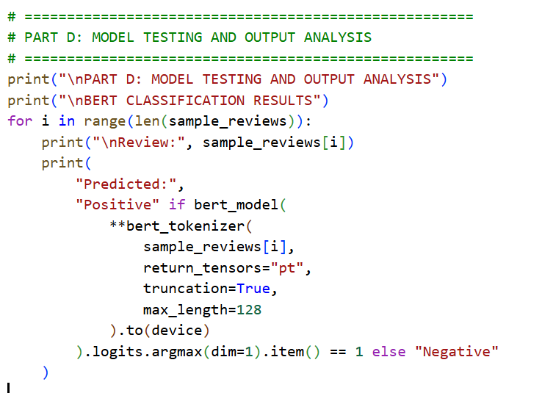
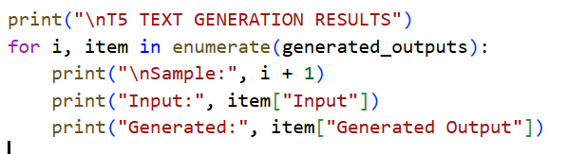
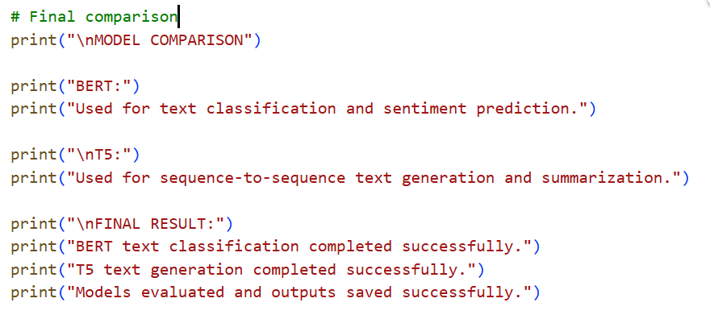

OUTPUT:
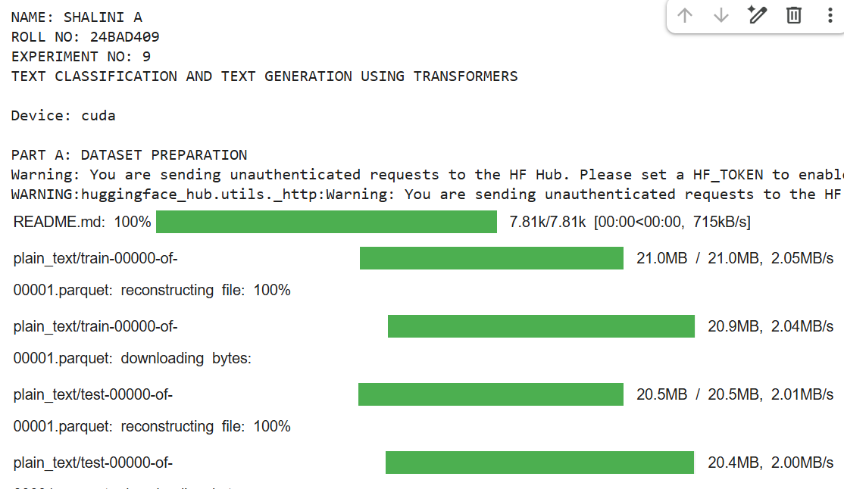
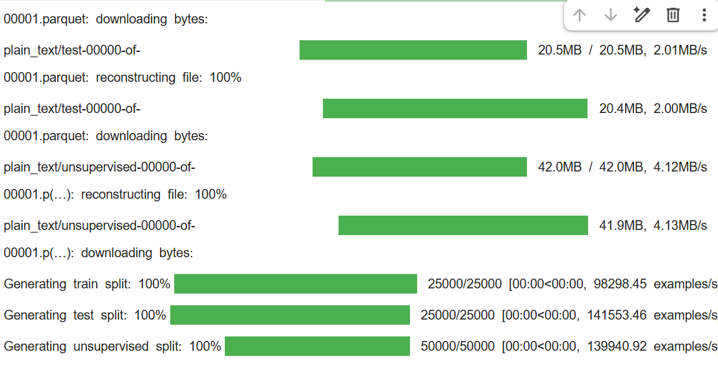
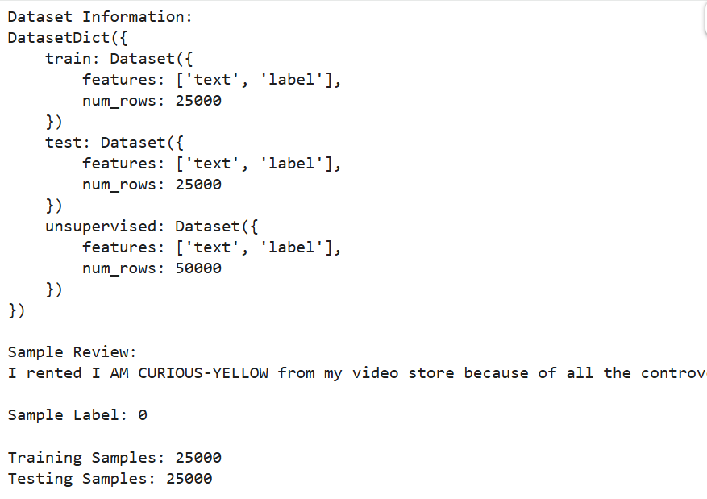
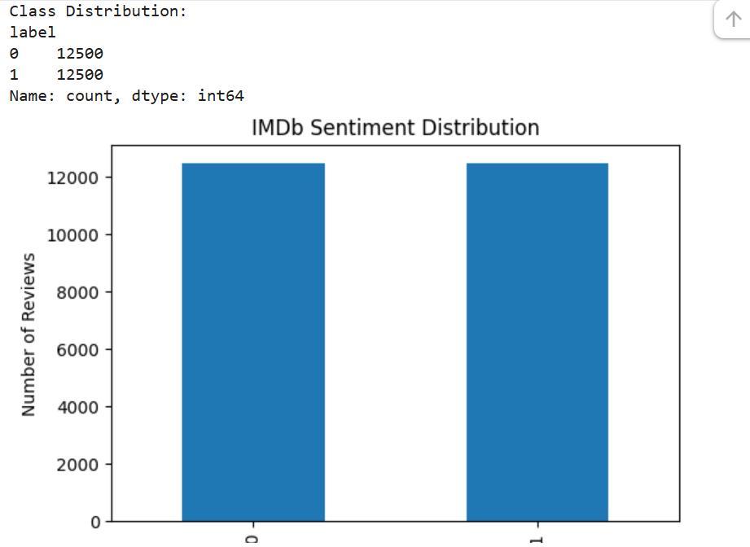

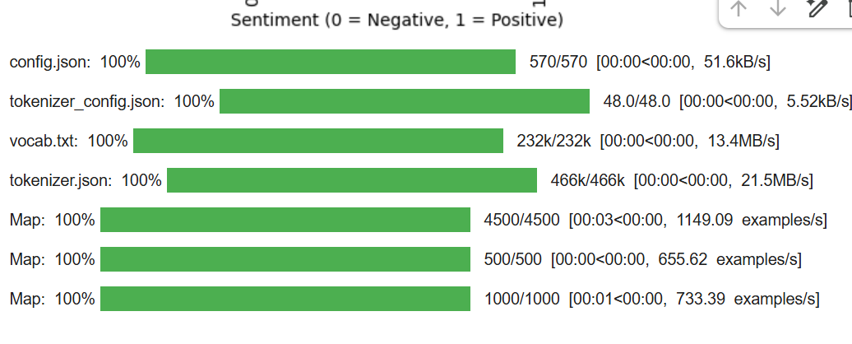
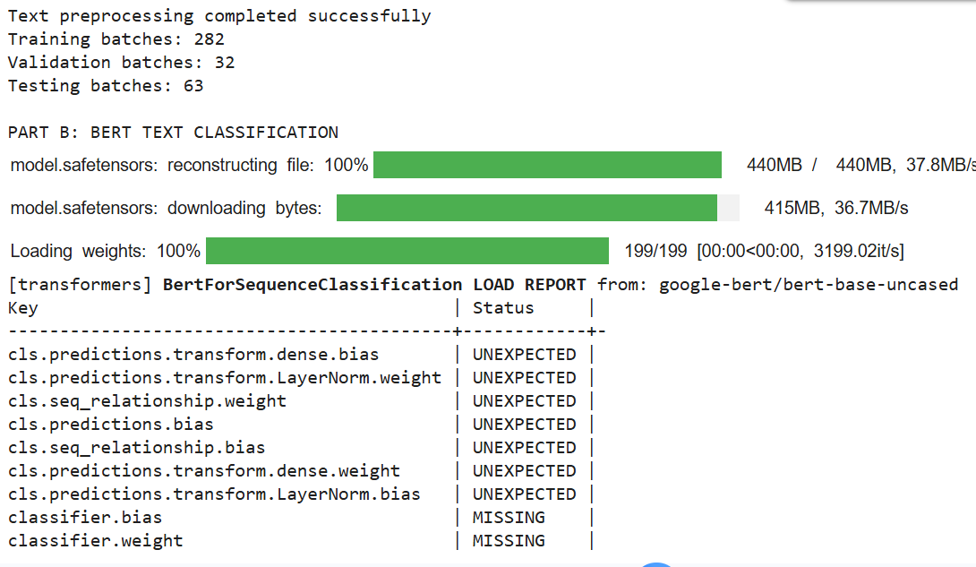
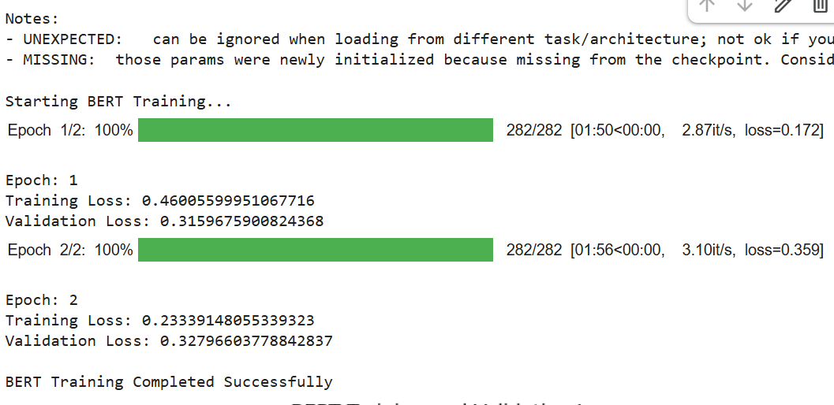
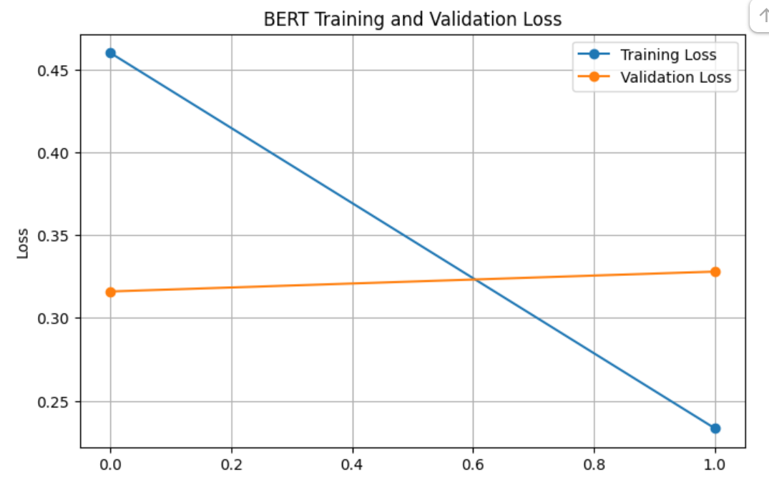
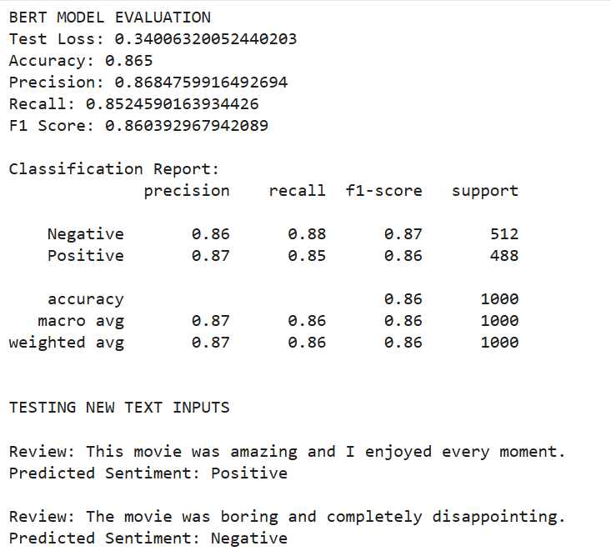
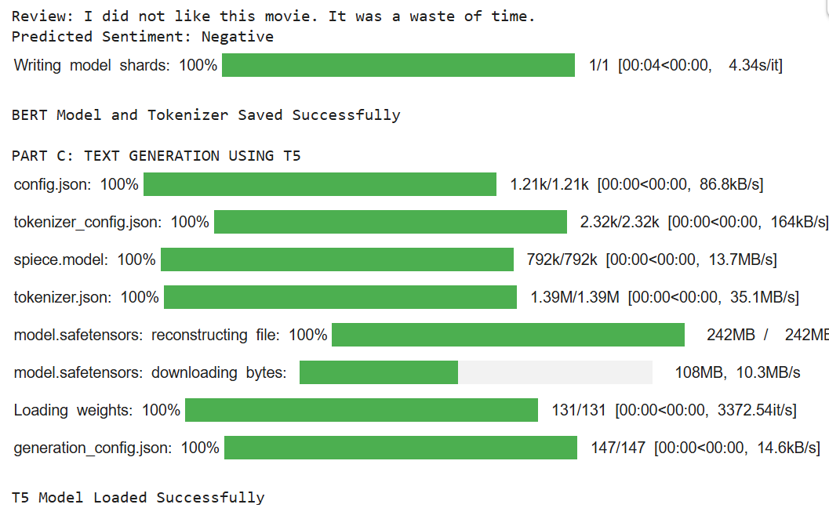
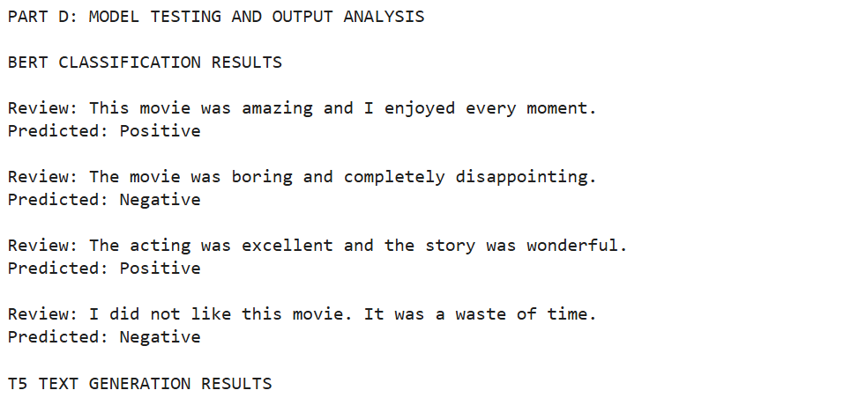
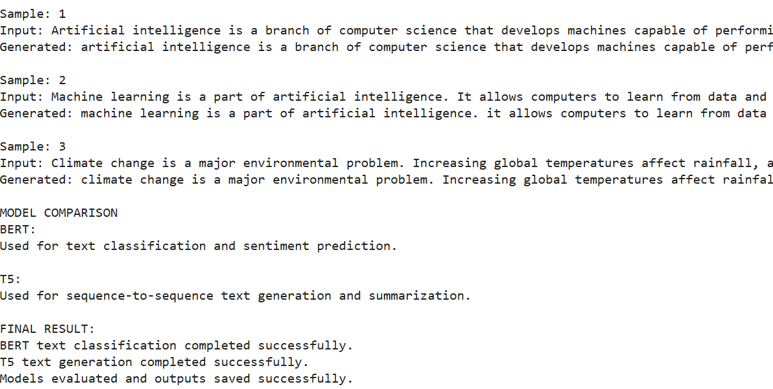

POST-LAB QUESTIONS (PROVIDE BRIEF ANSWERS TO THE FOLLOWING QUESTIONS)

- What is the role of BERT in text classification?
BERT understands the meaning and context of words in a sentence using bidirectional learning. It is used to classify text into categories such as positive, negative or spam.

- Why is tokenization required before providing text to a Transformer model?
Tokenization splits the input text into smaller units called tokens and converts them into numerical IDs. These IDs help the Transformer model understand and process the text.

- What is the purpose of fine-tuning a pretrained BERT model?
Fine-tuning helps a pretrained BERT model learn a specific task using a new dataset. It improves the model's accuracy and performance for that task.

- Mention any two-evaluation metrics used for text classification.
• Accuracy: Measures the percentage of correctly predicted results.
• F1-score: Measures the balance between precision and recall.
- What is the role of the encoder and decoder in a sequence-to-sequence Transformer?
The encoder reads and understands the input text and extracts its important information. The decoder uses this information to generate meaningful output text.

- What is the difference between text classification and text generation?
Text classification identifies the category or label of the given text. Text generation produces new text based on the given input or instructions.

- How does the maximum output length affect text generation?
Maximum output length controls how many tokens the model can generate. A higher value allows longer text, while a lower value produces shorter output.

- Mention one real-world application of Transformer-based text classification and one application of text generation.
• Text Classification: Detecting spam emails and identifying customer sentiments.
• Text Generation: Creating summaries, answering questions and generating automatic reports.

SUGGESTIONS FOR DATASETS & MODELS
Datasets:
- IMDb Movie Reviews – https://huggingface.co/datasets/stanfordnlp/imdb
- GLUE Benchmark – https://huggingface.co/datasets/nyu-mll/glue
- SST-2 Sentiment Classification – https://huggingface.co/datasets/nyu-mll/glue

Pretrained Models:
- BERT Base Uncased – https://huggingface.co/google-bert/bert-base-uncased
- T5-small – https://huggingface.co/google-t5/t5-small

ASSESSMENT
Description | Max Marks | Marks Awarded
Pre Lab Exercise | 5
In Lab Exercise | 10
Post Lab Exercise | 5
Viva | 10
Total | 30
Faculty Signature

